
Faculty of Applied Sciences
Bachelor of Science in Computing

COMP490 Final Year Project
Final Report
Academic Year 2025/26

Analysis of floor plan in a building based on image recognition technology
Project number: | 43
Student ID: | P2211681
Student name: | GUO YU XUAN
Supervisor: | JACKY TANG
Assessor: | Yanming, Ye
Submission Date: | XXX XX, 2026

Declaration of Originality
I, Guo YuXuan, declare that this report and the work reported herein was composed by and originated entirely from me. This report has not been submitted in any form for another degree or diploma at any university or other institute of tertiary education. Information derived from the published and unpublished work of others has been acknowledged in the text and a list of references is given in the bibliography.

[Your signature]
[Date of signature]

Abstract
An Intelligent Floor Plan Analysis System with Deep Learning and AI Consultation
This paper presents an intelligent floor plan analysis system that leverages deep learning techniques for automated architectural document interpretation. The system integrates two primary computer vision tasks: semantic segmentation for room identification and object detection for furniture recognition. The proposed system employs a U-Net architecture with ResNet34 encoder for pixel-level room segmentation, achieving 95.7% mean Intersection over Union (mIoU) on the test dataset. For furniture detection, we utilize YOLOv8, trained on 90 annotated floor plan images, reaching 92.25% mean Average Precision (mAP50). The system processes architectural floor plans to extract spatial information, including room boundaries, furniture locations, and precise area measurements through user-calibrated scale conversion. A web-based interface built with Streamlit provides interactive visualization capabilities, featuring Plotly-powered furniture detection with hover-highlighting functionality. The system is further enhanced with an AI consultation module powered by Ollama, enabling natural language interaction for design analysis and recommendations based on the extracted floor plan data. The system demonstrates practical applications in architectural design review, space utilization analysis, and automated property documentation. Experimental results show robust performance across diverse floor plan styles, with real-time analysis capabilities and an intuitive user interface suitable for both professionals and non-experts.
Keywords: Floor plan analysis, Deep learning, Semantic segmentation, Object detection, YOLOv8, U-Net, AI consultation, Computer vision
Acknowledgement
Write your own acknowledgement.

Table of Contents
1 Introduction 7
1.1 Societal, User and Business Needs 8
1.2 Objectives 9
1.3 Ethical Consideration 9
1.4 Summary 10
2 Background and Related Works 11
3 System Design / Methodology 12
3.1 Architectural Design 13
3.2 Data Modelling 13
3.3 Dynamic Modelling 14
3.4 [others …] 16
4 Result and Discussion 17
4.1 Outcome in Development Project 17
4.2 Software Verification 19
4.3 Security 19
4.4 Societal and Environmental Impact 19
5 Project Management and Risk Management 20
5.1 Project Time Management 20
5.2 Project Risk Management 21
5.3 Monthly Status Review 22
6 Conclusion and Further Work 23
References 24
Appendix A. Ethics Checklist 25
Appendix B. Reflection 28
Appendix C. Declaration of the Use of Generative AI in FYP 29

Table of Figures
Figure 1: Sample Entity Relationship Diagram 15
Figure 2: Sample activity diagram from Wikipedia 16
Figure 3: Sample state diagram from www.geeksforgeeks.org 16
Figure 4: Shopping UI in Amazon 19
Figure 5: Activity List 21
Figure 6: Precedence Diagramming Method Diagram 22
Figure 7: Gantt Chart (from Wikipedia) 22
Figure 8: Probability impact matrix before proposed solution 23

List of Tables
Table 1: Table of prioritized risk 22

Introduction
You set out to solve a problem in the Final Year Project. In this chapter, you must define the problem you want to solve, and establish its relevancy.
When someone reads this chapter, he/she wants to find answers to the following questions:
- Project aim and goal: What problem are you going to solve?
- Relevancy: Why is your problem worthy of solving? Why would anybody care? What is the use of it?
This chapter typically starts with an introduction that sets the stage for the problem. You typically start with a general picture and gradually bring the reader to the specific problem(s) you are going to solve. You should clearly explain the problem’s relationship with the overall context.
Example 1: people’s concern of health -> needs of air quality monitoring -> limitation of existing monitoring methods -> propose to develop a low-cost, portable air quality monitoring system
Example 2: Lots of information and events in university study -> diverse communication means between university and students -> needs of a personal, unified study information assistant -> propose to develop a mobile app to manage university communication with students
Notice that you should end this discourse with a succinct sentence to describe your project problem. This is essential in describing your work briefly in presentation and poster session.
Now if your problem is an important problem that is worthy of some effort to solve, someone else are likely to have attacked a similar problem before. You should mention these related works. Try to answer the following questions.
- What others have done to a problem similar to yours? What approaches did they take?
- Is it possible to apply their approach to your problem? Why?
- Explain clearly where the existing work came short. How is your work different from theirs? What were they focused on and why do you think a different focus or approach would yield better results?
You do not need to provide detail of these related works in Chapter 1. What is important here is to persuade the readers that you are not reinventing the wheel. Leave the detail of the related work in Chapter 2.
You may also highlight the major technical problems / challenges you encounter in design and implementation of your solution in this chapter. The details can be delineated in Chapter 3.
In general, Chapter 1 “Introduction” is difficult to write well and you will want to revise it after you have completed the implementation and found out what you eventually accomplish in the yearly project. Prepare to revise Chapter 1 in your final report draft in semester 2.
Some useful reference for writing introduction:
- UNC Writing Center: https://writingcenter.unc.edu/tips-and-tools/introductions/
In addition to the content above, the following three sections must be present in this chapter: “Societal, User and Business Needs”, “Objectives” and “Summary”.

Societal, User and Business Needs
In this section, you identify a combination of societal, user, business and customer needs for which your project will address. Briefly explain how your solution can cater to the different needs of users and the society. The following are some examples.
- Does your project help to mitigate an issue in the society or the environment? For example, an environmental monitoring system can provide data necessary to notify citizens of potential health issues. An environmental data analytics system can reveal plausible factors and causes of deterioration of air quality. In the development process, you can take into account the environmental needs to ensure responsible and sustainable practices. For example, an online food delivery platform may promote environmental awareness by encouraging the reduction of disposable plastic cutlery consumption.
- You may be designing an information system that streamline or improve some process in a business or organization. Explain how your system meets the business needs. For example, you may be applying artificial intelligence techniques in an online hotel price comparison and booking platform. This may increase the revenue of the platform by promptly providing desirable recommendation to customers. Another example is using computer vision techniques to detect possible cheating activities in an online learning system.
- When you design a solution to your problem, what user / customer needs do you need to pay attention to? For example, an e-learning system for young students should have a simple, easy-to-use user interface. The learning activities should be customized to fit the attention span of children. Another example is that customers may be confused by many similar products in an online shopping site, and in response you will design a product recommendation and comparison function to facilitate the shopping process.
In addition to the needs above, you may need to meet some regulation or restriction by laws, user safety, security, etc. For example, an online store that sells tobacco and alcoholic beverages also need to ensure strict adherence to relevant local laws and regulations. Give a brief explanation in this section.
This section should be concise, e.g. within 1 page. You can provide more detail of background material in Chapter 2. If these societal, user and business needs affect the design of your solution substantially, explain how you tackle the challenges in Chapter 3.

Objectives
In this section, you are expected to clearly state the project objectives to be achieved, and give a brief illustration of each objective.
Objectives are building blocks and/or steps performed to achieve the project goal. Objectives should be developed using the SMART approach, i.e. they should be Specific, Measurable, Achievable, Relevant and Time-bound. In latter part of the final report, you must provide evidence that you have accomplished the objectives.
- Sample objective 1 …
- Sample objective 2 …
- Etc.

Ethical Consideration
At the start of the project, you evaluate potential ethical issues of your project using the form in Appendix A. Mention this in this section, and refer the reader to that appendix.
If there are ethical issues, briefly explain how you handle them in the methodology or results here. Refer the reader to the relevant sections for detail. For example, you may explain how to anonymize data in a section about data pre-processing in Chapter 3.

Summary
The last section in this chapter is an annotated roadmap of the rest of the report. Don’t just repeat the chapter headings. Show the logic flow of the whole report! The following is an example quoted from a previous final report.
“This project refers to a slot performance analysis system using cluster computing. The report is organised in six chapters, briefly summarised as follows. Chapter 1 introduces and briefly describes the rationale behind this project, sets the major objectives and assesses the risks involved. Chapter 2 introduces the background information required to contextualise this project and discusses related works. Chapter 3 describes the high-level system architecture design, data modelling, and data-related high-level processes and methodologies involved. [and so on …]”

Background and Related Works
In this chapter, you provide background information for readers to help them understand your project. There may be more than one sections on background domain.
This chapter also provides detail about related works. In Chapter 1, you should have mentioned some related works and explained how your project is related to them when you discuss relevancy. If you want to provide detail of related works, include them in this chapter.
Call this chapter “Background” if all related works have been described in Chapter 1.

System Design / Methodology
Call this chapter “System Design” if you are designing and developing a system. Call this chapter “Methodology” if your project is research oriented. Other names are possible. Ask your supervisor for suggestion.
After formulating a problem, you provide detail on how you solve the problem in this chapter. You should:
- Provide sufficient information on how the project is accomplished. There should be enough detail for others to replicate your work.
- Perform detailed analysis of problem and methodical design.
- Exhibit analytical thinking. Compare alternatives in design and justify decision. Be aware of any shortcomings in design and methodology.
The required content in this chapter depends on the nature of your project. For system development project, you should elaborate your idea for solving the problem, with all the details of software analysis and design. This chapter focuses on designing a system that satisfies the needs and considerations outlined in the previous chapters. The design process typically begins with high-level designs, which are closer to the business data and features exposed to users. From there, the discussion progresses towards lower-level details, explaining how to effectively implement these designs using suitable development tools and techniques.
In general, you should include the following:
- Architectural design describes the high-level structural model of your system.
- Data modelling describes the structure of your database (and how you store other data like images), and the reasoning that support your design.
- Dynamic modelling explains the dynamic aspect your system, i.e. how your system changes and react when a user carries out some function.
- Design and implementation details of how the software system fulfils the societal, business and user needs that are mentioned in Chapter 1.
Use appropriate modelling tools and techniques (e.g. ER diagram, UML). Justify your design (e.g. discuss the implication and constraints, give reasons for making choice). Avoid including long or trivial code listings. You may include some programming code but show only the challenging or more interesting ones. Some cases that are worth of explaining are:
- Code pieces that are especially critical for correct system operation.
- Non-standard, innovative way (algorithm, data structure) to solve a problem.
- Unforeseen problems in implementation, and how you overcome them.
For research-oriented project, describe in detail how you carried out the experiments to verify your idea, and how your experimental data is obtained. The collected data should be adequate for verifying the hypothesis. You should include theoretical analysis (e.g. mathematical derivation, algorithm analysis) and well-formulate hypothesis to confirm / refute by the experiments.
Start this chapter with a paragraph that introduces the content of the chapter, describing the sections and preferably relating them into a coherent overall design of the whole system. You should break this chapter into sections and organize the content in a logical sequence. You may also break this chapter into several chapters, if this can improve the report structure.
The following are some common sections in a system development project.

Architectural Design
Describe the high-level structural model of your system, e.g. three layers, relationship between browser, server, and database, any JavaScript running on browser-side, any stored procedure running in database system. It is highly suggested to include an figure to visualize the relationship between components of the system architecture.
Next, describe the development tools and environment employed in your system. For instance, specify the programming languages used on the server-side, any libraries utilized for file uploads, and whether you leverage any Web UI frameworks like Bootstrap. Additionally, indicate the database system you have chosen to employ.
Explain your technical choices and provide reasoning behind each decision. For instance, if there are multiple Web UI frameworks available, explain the factors that influenced your selection. It would be helpful to include background information about the development tools and environment to provide suitable context for understanding the rationale behind your choices. Remember to include references in the "References" section to allow readers to access further information if desired.

Data Modelling
Describe considerations in data modelling (e.g. what are important entities? Are there any many-to-many relationships and how do you model them? How do you track the progress of a transaction in database?) Use ER diagram / UML model to illustrate your database schema. Also describe the format of files imported or exported by your solution. Give rationale behind your design. Examples: How does price change affect the data model? If a user can write review for the same product only once per purchase, does your database model enforce this relationship?
Describe your diagram and refer to your diagram in text. The following is an example. Refer to the figure (e.g. Figure 1 shows …) in your text.
Figure 1 shows the entity relationship diagram of the database of this project. The entity COURSE represents a course with a given name and course number, and a course may have 1 or more classes. A class is represented by the entity CLASS. It includes …
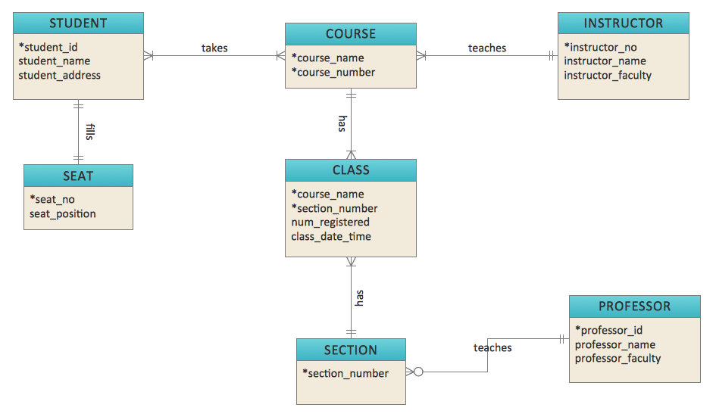
Figure 1: Sample Entity Relationship Diagram

Dynamic Modelling
Explain the interaction or dynamics of your system (e.g. state change of a purchase order, transfer of data in different state of a purchase order.) You may use activity diagram, sequence diagram, state diagram, etc.
Activity diagrams are commonly used to describe the flow of activities in a system or a process. An example is given in Figure 2. You must write a paragraph (or more) to explain the sequence and steps in the activity diagram. When the activity diagram includes many paths from the start to the end, you can help the reader to understand better by explaining the most common path first. Afterwards, describe the auxiliary paths and loops.

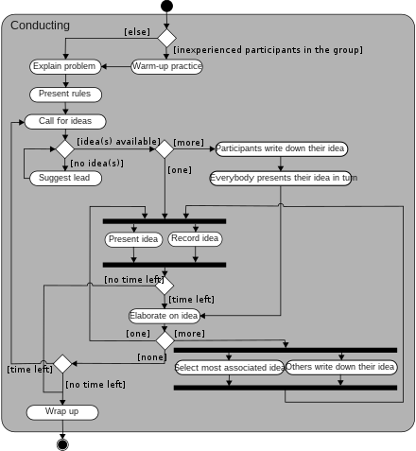
Figure 2: Sample activity diagram from Wikipedia
Another common kind of diagram in dynamic modelling is State diagrams. For example, you can use a diagram like Figure 3 to describe permissible transition between states of a purchase order and the events that trigger such transition.
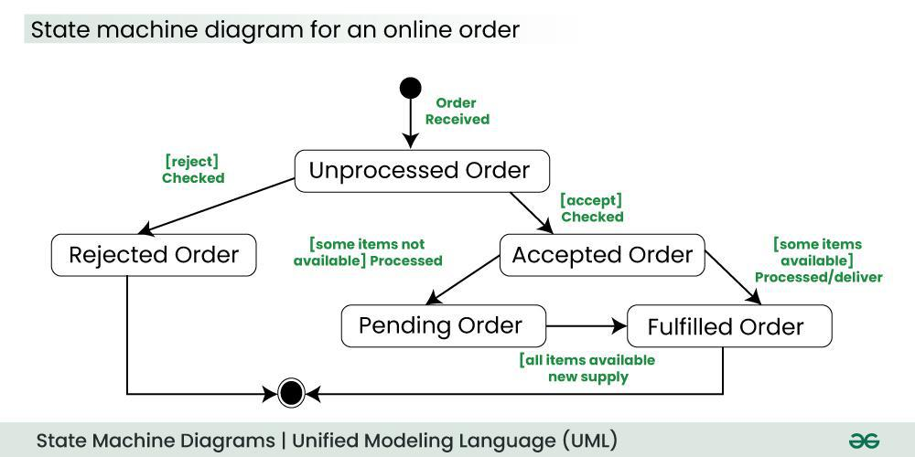
Figure 3: Sample state diagram from www.geeksforgeeks.org

Make sure small text in diagrams is readable when printed on A4 paper.

[others …]
Use additional sections as appropriate.

Result and Discussion
Chapter 4 provides detail of the project outcome. There is usually factual description of the software / hardware developed or experiment results. You may need to substantiate the quality of the results with software / hardware testing or statistical verification.
In addition, you have to evaluate the significance of the project outcome. First, you should discuss whether the project outcome meets the project objectives and provide evidence to defend your answer. You may also want to point out the contributions on a larger context, and compare your system with existing works. You can also discuss limitations. You should exhibit critical thinking in these discussions.
For system development project, this chapter includes two main parts:
- Outcome, which describes the software / hardware you have developed.
- Quality of outcome or software testing, which describes the testing process you performed to ensure quality.
- (If you have considered security issues, make sure you explain them here.)
You can use one or more sections for describing the project outcome or its quality. You can also break the content into two chapters: “Project Outcome” and “Software Quality”.
For research-oriented project, this chapter typically provides figures and tables to explain the experiment results. Discuss the significance of the results, and their implications. If appropriate, you can also split the content into two chapters, e.g. “Experiment Results” and “Discussion”.

Outcome in Development Project
You should describe the major non-trivial functions with captured screen images or other diagrams/figures. Refer to the figure in your text. For example, Figure 4 shows the shopping user interface in Amazon. Make sure that the text in the images is readable when the page is printed on A4 paper.
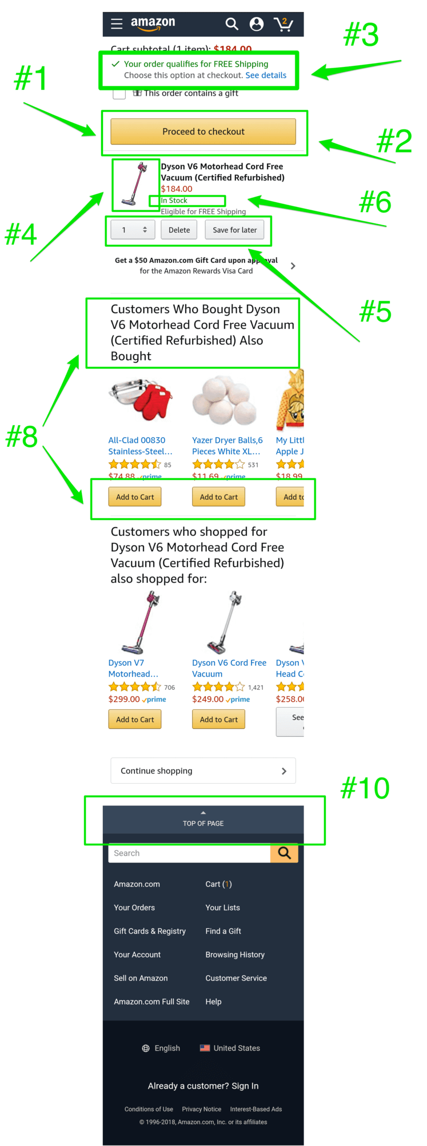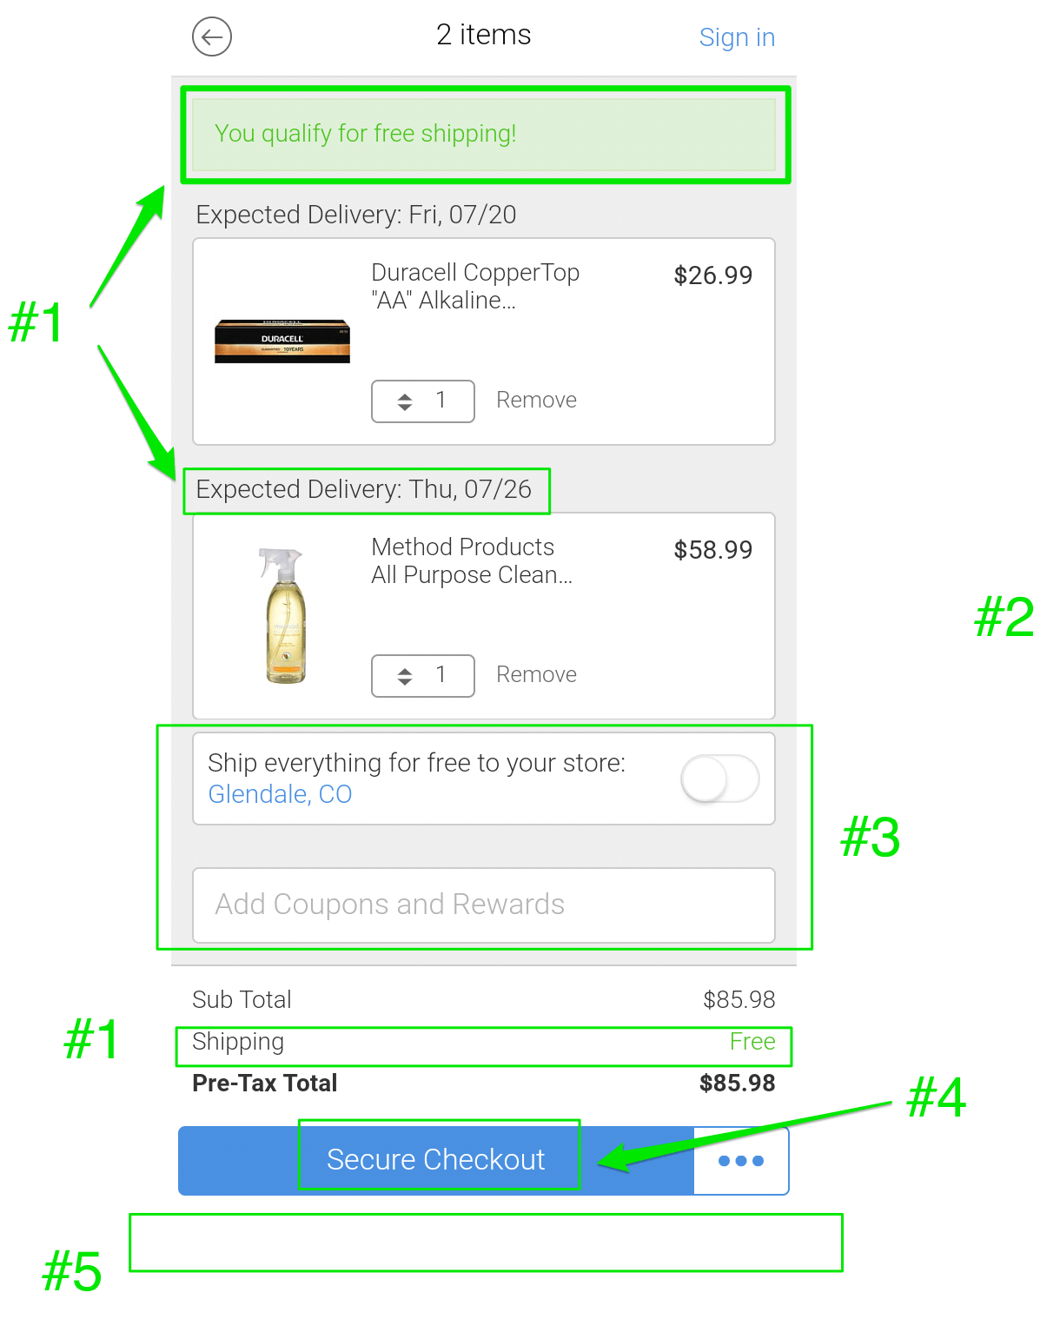
Images from https://www.growcode.com/blog/mobile-shopping-cart-design-mcommerce/
Figure 4: Shopping UI in Amazon

You DON’T need to describe every function with captured screen images. Focus on the major functions. Refer to the demonstration video for others where appropriate. As an example, the login process is usually simple, and is better explained in the video instead step-by-step short description with several screen captures. Moreover, you DON’T need to describe each minor step in a process with captured screen images. In most cases, text description is enough. This chapter SHOULD NOT be written as a user guide.
Organize the content of this chapter in a logical coherent flow. For example, in an online shopping system, you should explain the progress of a transaction as performed in your system. Organize your description in a logical coherent flow. For example, you can explain the steps of a purchase from product searching to shipment in a section, and then the catalogue maintenance in another section. Alternatively, you may separate customer’s features from vendor’s features.
This chapter should be detail enough for evaluating how well your system satisfies the objectives listed in Chapter 1. This enables your assessor to fully understand the project outcome without a system demo. You should also include sample report layouts (if applicable).

Software Verification
Describe the software testing approach employed by you to ensure the correctness of the system whether manual or automated testing is conducted. Specify the types of tests applied, such as debugging techniques, unit tests, integration tests, and acceptance tests.
Explain the design of test cases and/or the utilization of requirement-based tests. Elaborate on how you ensure the implementation of major, non-trivial functions with adequate data validation and error checking. Additionally, describe the sample data used to test the robustness and correctness of your system, while avoiding repetitive testing.

Security
Identify security vulnerabilities and implement suitable mitigation measures throughout the developed system, encompassing aspects such as data security, and protection against malicious user input, cross-site scripting (XSS), and cross-site request forgery (CSRF). In this section, provide an overview of these security measures from an external perspective of the system. Further design decisions and implementation details of these security measures should be provided in Chapter 3.
If you have conducted any relevant system tests, such as stress tests to assess resistance against DoS attacks, provide a description of the test results in this section.

Societal and Environmental Impact
Some projects may induce impact on the society or the environment. If applicable, evaluate the environmental and societal impact throughout the entire life-cycle of the solutions.

Project Management and Risk Management
This first paragraph should be an introduction to the content of the chapter and its purpose in the entire project.

Project Time Management
Exhibit an Activity List with the fields (Activity code, Description, Duration, and Predecessor). The activities are all the works involved in accomplishing the project. Before devising the list, you must identify all the activities involved to get the whole development project done. Although most of the functional requirements are given for this student project, you still need to identify all necessary activities as if you start everything from scratch.
Activity | Description | Duration | Predecessor
A1 | Planning the project schedule and task allocations | 4
A2 | User requirement analysis | 14 | A
.. | Xxxx xxxx | xx | xx
A14 | Data modeling | 5 | xx
.. | Xxxx xxxx | xx | xx
A26 | Implementation of feature x | 12 | xx
.. | Xxxx xxxx | xx | xx
A30 | Report writing (chapter 1&2) | 14 | xx
.. | Xxxx xxxx | xx | xx
Figure 5: Activity List
Draw a PDM (Precedence Diagramming Method) based on the Activity List. The PDM should be further specified with the 4 dates (early start, early finish, late start and late finish) for each activity. Exhibit the critical path(s).

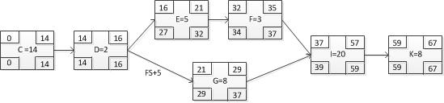
Figure 6: Precedence Diagramming Method Diagram
Show the schedule in the form of a Gantt Chart, as in Figure 7. Note that the left side of the Gantt Chart must match with the Activity List. (Sorry that the sample Gantt Chart below does not agree with the Activity List in Figure 5.) Show the Gantt Chart in a readable form.
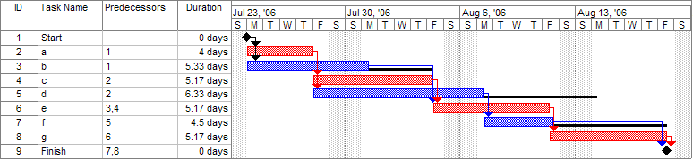
Figure 7: Gantt Chart (from Wikipedia)

Project Risk Management
Assess the potential project risks for your project and devise appropriate risk responses to each identified risk. A project risk is the one that poses negative impacts (don’t discuss the positive risks) on the project goals (achieving the target scope, time and cost). You must give at least 3 relevant, non-trivial potential risks and assess them as the given example below. A “non-trivial risk” means the risk having a significant value in at least one of the two aspects of risk assessment (probability and impact).
Risk 1: The crash of the storage hard-disk
- Description: xxxxxxx (general description of the risk; description of what causes you to perceive this as a risk; etc.)
- Probability of occurrence: low to medium level (low/medium/high)
- Impact: It is disastrous that all program codes and data xxxx, leading to xxxxx (how this affects your project goals)
- Response: xxxxxxx (the strategy to resolve the difficulties caused by the risk)

List the identified risk in the order of priority in a table. Exhibit the effectiveness of your responses to the risks with the probability impact matrix before and after the proposed response. Sample formats are provided below.
Table 1: Table of prioritized risk
Priority | Risk Identifier and Description
1 | Risk 1: short description
2 | Risk 2: short description
3 | Risk 3: …
4 | Risk 4: …

Probability | High |  |  | Risk 1
 | Medium |  | Risk 3 | Risk 2
 | Low
 |  | Low | Medium | High
 |  | Impact
Figure 8: Probability impact matrix before proposed solution

Monthly Status Review
Attach the monthly status review of your project here. You have to briefly report what tasks you have accomplished and your plan for the coming month.

Conclusion and Further Work
Conclude your work by stating the contributions and their significance in larger context. It should do the following.
- Summarize the main contributions of your work, and how it fulfilled the objectives. If applicable, restate the hypotheses and describing how the observed results met those expectations.
- Describe how your work may contribute to existing works in the field. How does your work fit in and support existing work in the field?
- Point out ways to extend your work, or how to overcome limitation of your work.
Some questions you can try to answer as further work are as follows: Should somebody else follow up along the lines of your work, what would you recommend doing next? In other words, what would be a good topic or topics for a new project related to this work? Can your work be applied in other areas? What are the limitations?

References
[1] Harold Abelson, Gerald Jay Sussman, and Julie Sussman. Structure and Interpretation of Computer Programs. MIT Press, Cambridge, Massachusetts, 1985.
[2] Robert Baumgartner, Georg Gottlob, and Sergio Flesca. Visual information extraction with Lixto. In Proceedings of the 27th International Conference on Very Large Databases, pages 119–128, Rome, Italy, September 2001.Morgan Kaufmann.
[3] Ronald J. Brachman and James G. Schmolze. An overview of the KL-ONE knowledge representation system. Cognitive Science, 9(2):171–216, April–June 1985.
[4] Georg Gottlob, Nicola Leone, and Francesco Scarcello. Hypertree decompositions and tractable queries. Journal of Computer and System Sciences, 64(3):579–627,May 2002.
[5] Georg Gottlob. Complexity results for nonmonotonic logics. Journal of Logic and Computation, 2(3):397–425, June 1992.
[6] Hector J. Levesque. Foundations of a functional approach to knowledge representation. Artificial Intelligence, 23(2):155–212, July 1984.
[7] Hector J. Levesque. A logic of implicit and explicit belief. In Proceedings of the Fourth National Conference on Artificial Intelligence, pages 198–202, Austin, Texas, August 1984. American Association for Artificial Intelligence.
[8] Bernhard Nebel. On the compilability and expressive power of propositional planning formalisms. Journal of Artificial Intelligence Research, 12:271–315, 2000.
[9] Ivan Marsic. A short guide for writing a thesis. http://www.ece.rutgers.edu/~marsic/thesis-guide.html, 2004 [Mar. 6, 2014].
[10] Matlab documentation. http://www.mathworks.com/help/?s_tid=hp_ff_s_doc [Mar. 6, 2014].
[11] George Sparling. Spacetime is spinorial; new dimensions are timelike. arXiv:gr-qc/0610068v1, 2006.
[12] Ryan Rifkin. Everything old is new again: a fresh look at historical approaches in machine learning. Ph.d thesis, MIT, 2002.

Appendix A. Ethics Checklist
Name of student:
(leader of the team, if applicable)
Student number:

Programme: | BSc in Computing BSc in AI  MSc in Big Data and IoT  PhD in Computer Applied Technology
Module: | Final Year Project
Title of project:
Supervisor:

Instructions
Answer the following questions honestly. If your answer falls into a shaded box, you must provide additional information on how you will handle the related ethics issues on the last page of this form.

Project summary
Please provide more information on your project/dissertation proposal below (100-200 words).

Participants (Consent procedures and possible harm)
 |  | Yes | No | N/A
1 | Does your project include human participants?  If no, you can skip the rest of this section.
2 | Will any of the participants be from vulnerable groups, e.g. children under 18, people with communication difficulties, patients in hospital?  If yes, please specify: _______________________
3 | Will you tell participants that their participation is voluntary?
4 | Will you obtain written consent for participation?
5 | Will you tell participants that they may withdraw from the research at any time and for any reasons without penalty?
6 | Is there any realistic risk that any participants could experience either physical or psychological distress or discomfort?

Data Protection
 |  | Yes | No | N/A
7 | Will any non-anonymised and/or personalized data be generated and/or stored?
8 | Will you have access to documents containing sensitive data about living individuals?

Researcher Safety
 |  | Yes | No | N/A
9 | Will you be exposed to any risks greater than those encountered in their normal study/working life? E.g. operation of non-standard equipment or extended
10 | Will you be exposed to highly addictive or illegal activities (e.g. gambling, drugs) during the research?

Please explain how the identified potential research ethics issue will be handled.

Any other issues?

Declaration
Student  I have read the instruction carefully and reported honestly the potential ethics issues about the project.  ─────────────  Date: | Supervisor  To the best of my knowledge, the student has reported honestly the potential ethics issues about his/her project.  ─────────────  Date:

This form is largely based on the ethical approval documents from Cardiff University https://www.cs.cf.ac.uk/ethics/ and University of Glasgow http://www.dcs.gla.ac.uk/ethics/

Appendix B. Reflection
Reflect on the progress of the yearly project. Can use first person pronoun to write.
This appendix is required!

Appendix C. Declaration of the Use of Generative AI in FYP
Please make sure you understand the policy about using generative AI, and such use must be explicitly acknowledged. The teacher/supervisor responsible for the assessment will provide specific guidance regarding acceptable usage. Failure to follow the rules for your work constitutes academic dishonesty.
Please tick either one below.
☐ I have used generative AI in this assessment work
☐ I did not use generative AI in this assessment work (please go to sign)
Generative AI tool used (name and version): | ________________________________________________________
For each relevant area, briefly describe how the information was generated, as well as explain how the output was used in your work. Put N/A if not appropriate.
Type of usage | GenAI assistance received | Student action on generated content
Brainstorming and idea generation
Literature review and background research
Data analysis
Programming support
Visualization and diagram production
Text Rewriting and Drafting
Other (please specify):

Student signature:
Date:

